Notes from reading are most effective when they clearly highlight the main points and start to make connections to other material. Making effective notes helps you to think actively about your reading and critically analyse the material, rather than passively just reading.
The reading notes sheet (on the next page) can be used as a guide to help you think more analytically about the material.
- There are some basic questions (grey boxes) to help you put the reading into context (e.g. ‘How is this related to my course/topic/ lecture/assignment?’).
- Some more probing questions (white boxes) to get you to think more deeply about the reading (e.g. ‘Who does the author work for?’).
- The questions in bold (e.g. ‘Why am I unsure?’) are asking for your opinion i.e. your critical analysis of the reading.
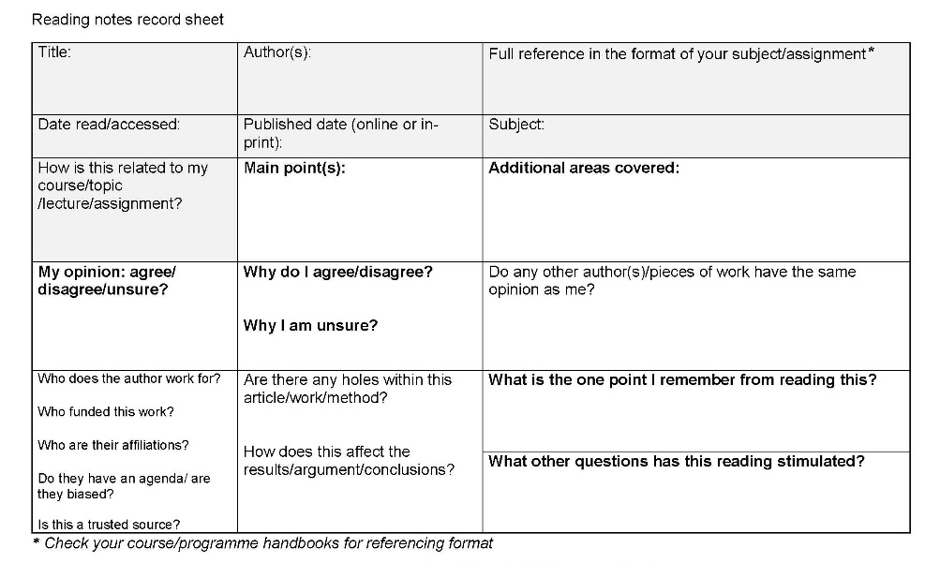
Reminding yourself of the questions, by looking at the reading notes sheet before reading, will help prime your brain to look for key information whilst you’re reading.
An even more effective reading method would be to look at the reading notes sheet first, do the reading, put the reading away, and then complete the sheet by recall.
You can use the sheets either as an e-copy or print them out and hand write them. Having all your notes organised in the same way will help you see main points and connections more clearly.
The questions on the reading notes sheet are a starting point, think about what sort of other questions you could ask that are more specific to your topic or assignment.

Title: | Author(s): | Full reference in the format of your subject/assignment*
Date read/accessed: | Published date (online or in-print): | Subject:
How is this related to my course/topic /lecture/assignment? | Main point(s): | Additional areas covered:
My opinion: agree/ disagree/unsure? | Why do I agree/disagree?  Why I am unsure? | Do any other author(s)/pieces of work have the same opinion as me?
Who does the author work for?  Who funded this work?  Who are their affiliations?  Do they have an agenda/ are they biased?  Is this a trusted source? | Are there any holes within this article/work/method?  How does this affect the results/argument/conclusions? | What is the one point I remember from reading this?
 |  | What other questions has this reading stimulated?
* Check your course/programme information for the correct referencing format to use.

