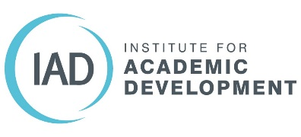

IAD paper reduction policy
The IAD is committed to paper reduction and sustainability in our communications and branding. Our three key areas for action on paper reduction are:
- Printed handbooks for courses
- Flyers
- Meeting notes
We also encourage all staff to take the following basic actions:
- Sharing documents electronically to avoid printing wherever possible
- When printing is unavoidable, print double sided and black and white
- Use the draft format where possible to further conserve resources
Handbooks
The vast majority of our printing goes towards course handbooks. It costs us in time, electricity and the cost of the paper, as well as the inconvenience to other colleagues who have to wait for their own printing. The IAD has moved towards electronic copies of course handbooks and workbooks as far as possible. Sending out electronic copies in advance is better practice in terms of mainstreaming adjustments for disabled participants.

IAD Flyers
We will aim to gradually reduce the numbers of flyers printed by creating fewer high quality flyers and trialling alternatives such as business cards with web links. Rather than giving flyers to all participants at a given event we will provide a smaller selection of flyers which participants can take if they want a print copy. We will enhance our online presence using more images and video.

Note taking in Meetings
We propose to minimise (with the aim of eventually eliminating) the use of paper in meetings by encouraging staff to take notes electronically. We have provided technology and training to enable this. We will aim to use whiteboards rather than flipcharts wherever possible, photographing the whiteboards to record them.

Version: 30/7/2018

