e-Professionalism

Introduction
Many students (and staff) will already be users of a range of social media and online platforms. This guide is intended to support you, provide information and pose questions in order for you to think about your activity online in the context of your emerging professional identity.
Key definitions

E-professionalism is the way you engage yourself online in relation to your profession, including your attitudes, actions and your adherence to relevant professional codes of conduct.

Professionalism. Keep in mind the principles underpinning professionalism: honesty, integrity, reliability, responsibility, respect.

Your digital footprint is the data you leave behind when you go online. It's what you have written, what others have posted about you, where you have been, images you are tagged in, personal information and social media profiles.

Social media are online spaces where users are enabled to publicly connect, collaborate and share their own content, including social networking sites with a highly visible identity or profile (e.g. Facebook) and applications where a users’ profile may be less visible (or anonymous) such as WhatsApp, SnapChat and YikYak.

E-professionalism – Why is it important?
An increasing number of professional organisations recognise the importance of using social media and the possible benefits, including:
- Increasing audience engagement and promotion
- Widening and improving communication
- Providing professional development support and networking opportunities
- Engaging with partners and stakeholders, including service users and consumers
It is important for you to think about how you manage your activity online in the context of your emerging professional identity (or identities) and what you need to do to manage an effective online presence and your digital footprint. | 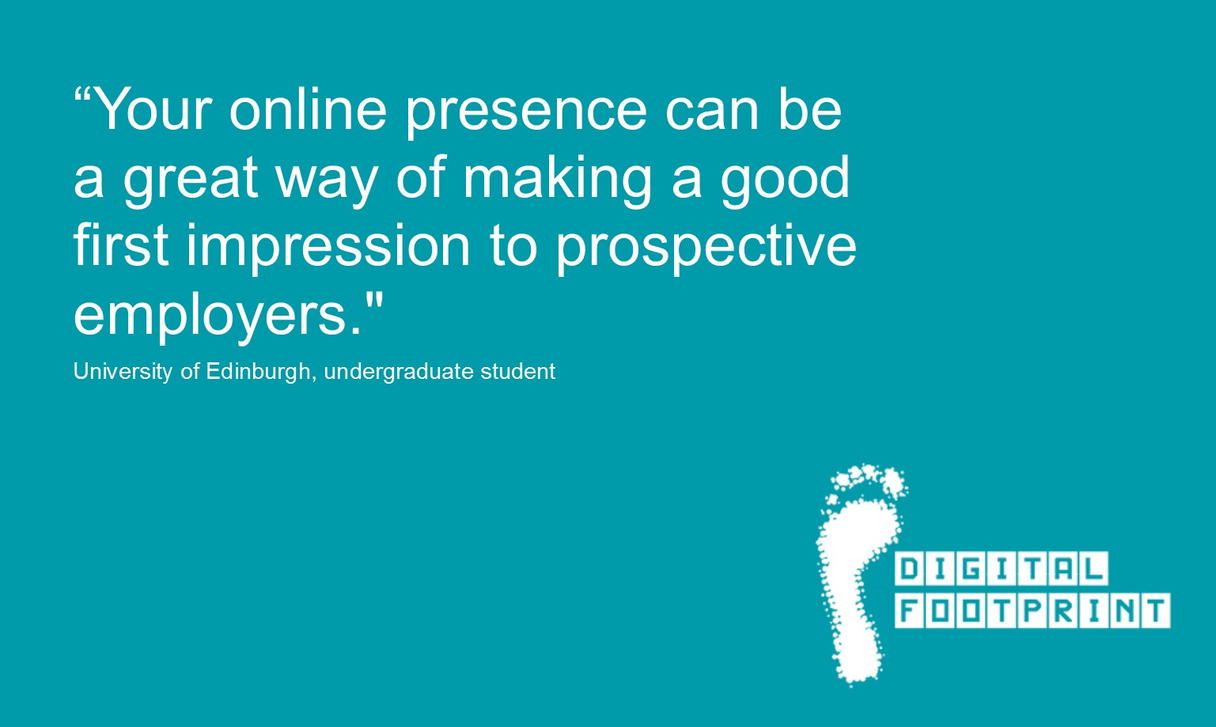
Professional Bodies Guidelines
A growing number of professional organisations publish guidelines on the use of social media (an indicative list can be found at www.ed.ac.uk/iad/digitalfootprint). It is important to investigate whether the guidelines are applicable to you as a student (as a para-professional, e.g. Nursing student) as well as how they will be relevant to you once you graduate. If you are unsure which professional field you will work in, it is advisable to look at the guidelines and familiarise yourself with the key points. Much of the guidance is common sense but there are some areas which are more specific and set out clear guidance on what you should/shouldn’t do. If in doubt, err on the side of caution.

What steps can you take?
The following questions provide a starting point for you to think about e-Professionalism.

Who are you (now)?
- Think about what your digital footprint looks like at present? Does your current digital footprint represent you accurately? For example, if someone Googled you, what would they find and would this be beneficial or a potential disadvantage for working in your chosen or preferred profession(s)?
- Does your online profile(s) describe you in a personal or professional context? e.g. do you identify with your chosen profession/field of study?
- Is your online presence accurate and up to date?

Who are you going to be (in the future)?
- What information do you want someone to find, if they search for you online?
- Do you want to keep your professional and personal identities separate or blended?
  - What advantages/disadvantages might this have both in the short and longer term?
- If you have multiple online identities on different platforms, is it obvious that they belong to you?

How do professional bodies’ guidelines impact on you?
- Which professional organisations are likely to be relevant to your chosen or preferred profession(s)?
- Are the professional organisations relevant to your public/visible social media presences? Read any available guidance or, if no guide exists in your specific area, consider looking at associated professions or consult the University of Edinburgh guidelines (or School guidelines if applicable).
- Ensure you take action to manage (improve, adjust, separate) your profile(s) accordingly.

For students with a clear vocational pathway this will be a straightforward question to answer. For others, this may be a question you need to revisit at different stages of your studies as you gain a clearer idea of your likely profession following graduation.

Social media guidelines and codes of conduct are profession specific. For example, in some circumstances it might be acceptable to ‘friend’ (online) those you are working with but for others it may not be appropriate or is not permitted e.g. when working with vulnerable adults or children.

What can you do to create and maintain an effective online presence?
- Review existing privacy settings and make adjustments where necessary. For instance, you may be able to delete old posts/photos or update settings to ensure someone must ask for your approval before they tag you in an image or location.
- Find out what (and how) information is used by the different social media sites so that you can make the best and most appropriate use of them.
- Consider who your friends and f ollowers are, and who follows you?
- Reflect on the identity you are curating online: how might your current profiles and digital footprints impact on your professional standing later?
- Think ahead: how might your use of social media change if you think of yourself as a professional-in-training rather than as a student?
- Make a plan: what do you need to be doing now to plan for, build and develop your identity as a professional?

The legal implications of using social media information to inform recruitment are still developing. It is not necessarily contrary to employment or equalities law for an organisation to take into account non-protected information in the public domain about a candidate.

http://www.lawscot.org.uk/rules-and-guidance/section-e-general-guidance/division-b-the-management-of-files,-papers-and-information/advice-and-information/social-media-–-advice-and-information-for-the-legal-profession/

What might an online presence look like and how can it be made more effective?
- Please read the hypothetical case study of “Joe”, which should offer you some ideas on how to improve your online presence.
- Please read the checklist below, which includes a number of practical suggestions.

CASE STUDY (Please see www.ed.ac.uk/iad/digitalfootprint)
Please download the case study which provides a hypothetical example of how e-professionalism could be applied to a range of online accounts/platforms and activities. The case study also provides actions which can be taken to improve an effective online presence and ensure an e-professional approach to managing your digital footprint.

CHECKLIST for maintaining an effective online presence

Voice. Are you writing in a personal or professional capacity? Should the context in which you are writing alter the (formal/informal) language and tone of your voice? Think about adhering to professional boundaries (content and style), whilst developing your own voice. What use of language, grammar and punctuation is appropriate/inappropriate in the context of your different online activities?

Exemplars. Can you identify key individuals within your field who have an effective professional online/social media presence? What do they do well? How does their practice inform how you might develop and manage your own professional identity?

Off-limits. Which subjects, if any, are off limits and/or sensitive in the professional context in which you plan to operate? For example, inter and intra-organisational politics, the identification of individuals, information about legal proceedings, intellectual property, copyright, illegal activity and anything breaching ethical codes of conduct (formal/informal) or principles of commonsense.

Representation/Misrepresentation. Are you showcasing your best personal attributes, skills and experience as part of your current online presence? Does that presence align well with how you present yourself offline (e.g. in job or placement applications)? Does your activity reflect poorly on you or any organisation with which you might be associated in the future? Are you misrepresenting an individual, organisation or an issue?

Interaction. Think about how often you post/update, comment, and interact with others in your various online spaces. Consider how you monitor and manage interactions as you should respond to comments/interactions in a timely fashion, and engaging productively with professional issues and current debates. If you do make a mistake do not be afraid to edit or delete your comments/shared item and admit to making a mistake.

Forward planning. Think about how you plan to develop your online professional presence over time. How does your ongoing posting/updating activity fit with your long-term vision? Review your online presence regularly.

Permanence. If you are thinking about no longer updating a personal website or are planning on leaving a social networking site, consider your exit in light of your longer-term online strategy. Think about consistency (of your own professional brand) and be realistic about how your commitments might impact on your online activity. It would be better to have a small number of regularly updated accounts than multiple stagnating profiles. It is also important to think about the permanence of what you share online. Deleted information may still be visible or accessible. Similarly, if you delete a profile it does not necessarily mean your profile (in that context) has been permanently deleted.

Professionalism. Keep in mind the principles underpinning professionalism: honesty, integrity, reliability, responsibility, respect.

Useful Additional Resources www.ed.ac.uk/iad/digitalfootprint
Digital Footprint MOOC (free 3 week online course ~9 hours)
Fact sheets, guidelines and other information can be found

Contact Information
Digital Footprint Service, Institute for Academic Development
Email: iad.digitalfootprint@ed.ac.uk
Web: www.ed.ac.uk/iad/digitalfootprint

Digital Footprint Service Partners
