Student-authored computer-assisted learning (CAL) on the Edinburgh MBChB – lessons learned – Poster P9

Christopher J Graham¹ (christophergraham@doctors.org.uk), Rhianna McIntyre-McClure¹, Sophie Vennard¹, Michael Buckton¹, Rebecca M Reynolds^{1,2}, Ruth Andrew², Steven D Morley^{1,2}

1 = Edinburgh Medical School, University of Edinburgh
2 = Deanery of Clinical Sciences, University of Edinburgh

CAL in the Edinburgh MBChB

A suite of staff-authored Endocrinology and Diabetes (E&D) CAL packages has been well received by University of Edinburgh (UoE) medical students. A new CAL package was created by a UoE medical student (CJG), supervised by faculty staff, to promote understanding of the thyroid gland in health and disease during the MBChB2 E&D module. The thyroid CAL package has since acted as a template to create new student-authored calcium CAL (RM-M, SV, MB).

Student evaluation of CAL

Student evaluation of the E&D CAL suite, including the thyroid CAL package, was sought via on-line questionnaires (in 2015, 2016, and 2018) comprising Likert scale questions and free text responses.

The cumulative results of the audits in 2015 (n=22), 2016 (n=45) and 2018 (n=21) regarding thyroid CAL are presented here:
- All student user respondents (N=88) rated the thyroid CAL package as ‘Good’ or ‘Very Good’
- Students reported that the CAL package is interesting, logically organised, user-friendly, and helpful for reinforcing key LOs
- Since 2017, the Edinburgh MBChB has included a clinical E&D attachment in Year 4. Year 4 students support the use of MBChB2 E&D CAL for revision of basic biomedical sciences material on clinical rotation (n=4, 2018 audit)

Benefits to student users and student/staff co-creators

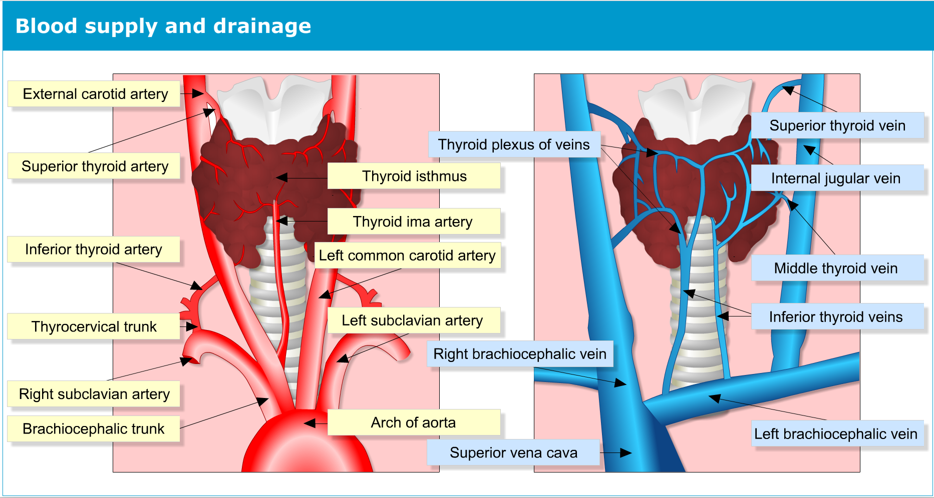
Benefits to student users:
Example of graphic-design image - Image later animated and used in ‘drag and drop’ question
- CAL is flexible: students can learn at their own pace, at a time that suits them, and revisit whenever, without geographical restriction
- CAL is interactive: regular questions and interactive animations encourage pro-active learning and aids concentration
- Whilst complementary to lectures, CALs are in an alternative format which may suit different learning styles

- Student authorship aids the clear communication of pertinent information - student authors are well equipped to identify this key information and present it in a format accessible to fellow students
“Making information more accessible is at the heart of CAL. I believe student-led CAL is vital in achieving this” (RM-M)

Benefits to student creators/authors:
- Learn how best to present information to others, a vital skill for every teacher, and doctor
- CAL creation develops communication skills in a variety of forms (written, spoken, image-based) and between many different people (staff-student and student-student)
- Promotion of co-operative learning between students and tutors, emulating future professional environments and the ethos of lifelong learning
- Above all, CAL authoring supports the development of teaching skills
“My involvement has made me appreciate the value of teaching as an effective method of learning” (SV)

Benefits to staff supervisors:
- Enhancement of teaching skills
- Uncover which taught areas require extra focus and clarification
"Working with students to create CAL has been very rewarding, and I’ve learnt a lot from them! Student users appreciate the student insight, and faculty review ensures high standards" (SDM)

Sustainable system of senior students mentoring junior students

There will soon be a sustainable group of senior students mentoring junior students in CAL creation in Edinburgh Medical School.

“Mentoring junior students not only allows me to update my understanding of key biomedical topics, but also prepares me to teach and support others – vital skills I will use from August as a doctor" (CJG)

The future of CAL in the MBChB

The first of its kind student-authored patient case study CAL has been created by CJG and will be reviewed by senior medical students and faculty this summer. The thyroid CAL is being used as a template to produce student-authored CAL on calcium metabolism, diabetes, and multiple endocrine neoplasia, amongst others. Student-student and student-staff partnership is key.

Conclusions

- The student-authored thyroid CAL package was equally well-received as its faculty-authored counterparts – this CAL is being used as a template for new student-authored CAL
- Students benefit from both using and creating CAL content
- Staff enhance their teaching skills in CAL co-creation, and learn which taught areas require extra focus and clarification

Take home message: Although our student-authored CAL is firmly rooted within the Edinburgh MBChB, the integral CAL principles of breaking down complex subject material, allowing student control of the pace of learning, and providing additional routes to achieving core LOs are likely to be applicable across the UoE

