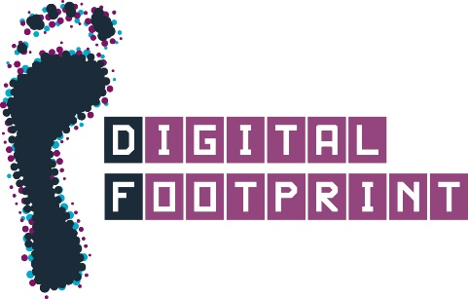 Which Social Media platforms do you use?
_____________________________________________________________________________________________

Facebook
YikYak
Twitter
Instagram
Snapchat
WhatsApp
Academia.Edu
Youtube
Blogs
LinkedIn
Google+
Do you use something we’ve not mentioned? Tell us:
© University of Edinburgh, CC BY (Digital Footprint Service, IAD)

